**1) Are there options to cancel an order once placed and get refund?**

There is no way to cancel the order from the app/online, but if you want to cancel your order, then you need to contact with customer service people (over the phone). They deliver your foods to your door before 26 minutes (average time), that’s mean they stat the preparation for your food from that second you hit the conform order button, and they take about 6 minutes to make your food. (it’s very hard to cancel your order and get refund).

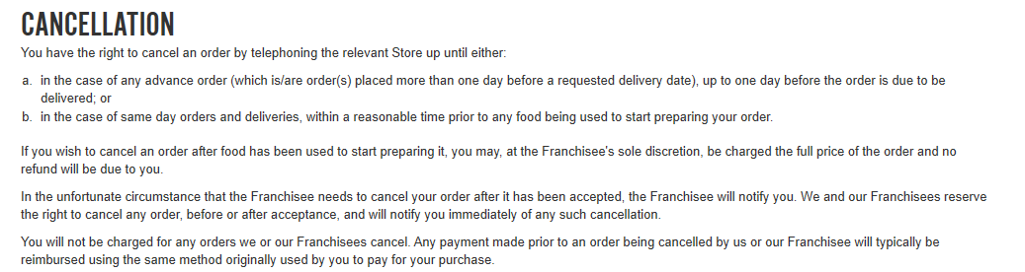

**2) Can allergy information be provided in all items? What else?**

Yes, all allergic information is provided on a different website that call “corporate.dominos.co.uk” <https://corporate.dominos.co.uk/> , also they provide a short and easy understandable allergic information on the website/app. You can see them by click the “Allergen Information” also they provide each store’s Food Hygiene Rate. They don’t suggest us any stores who has 2 or less than that rating points.

